AN LAC SEAFOOD CO., LTD. (HK216)
No. 38, 2A Street, Hung Vuong South – Tran Van Kieu North Residential Area, An Lac Ward, Binh Tan District, Hochiminh City, Vietnam.

No.: 06/ALC/ 2011
STATEMENT

TO.: SHING YUEH INTERNATIONAL CO., LTD.

DATE | INVOICE NO. | AWB | TOTAL
19 FEB. | 016/ALC | 695 3394 9311 | 8,567.63
25 FEB. | 017/ALC | 695 3394 9355 | 6,588.54
28 FEB. | 018/ALC | 695 3394 9366 | 8,031.60
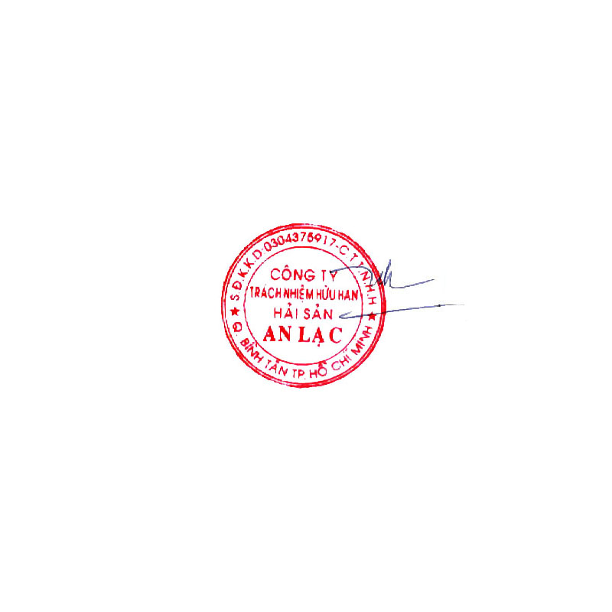  GRAND TOTAL |  |  | USD 23,187.77

Says: US DOLLARS Twenty Three Thousand One Hundred Eighty Seven And Seventy- Seven Cents Only.
AN LAC SEAFOOD CO., LTD.
Account No. : 1402 1485 100 3419
Name Of Bank : EXIMBANK, DISTRICT 4 BRANCH, HOCHIMINH CITY, VIETNAM.
SWIFT : EBVIVNVXQ04
AN LAC SEAFOOD CO., LTD.

Lê Thị Hoa

